November 2015

NEWSLETTER

Heath Street Baptist Church
Hampstead

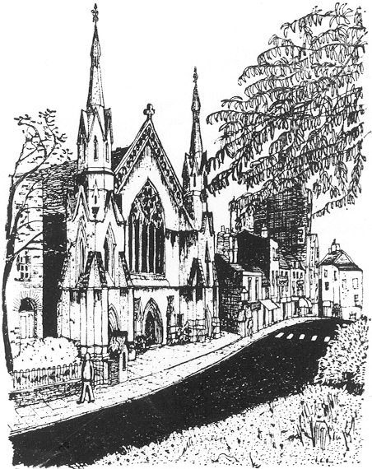

Minister: Ewan King
Newsletter No. 1028
Secretary’s news
Lots of reasons to be cheerful…
We had a good discussion at the September Church meeting about how to make better use of everyone’s time and effort in running our activities and how to get our lovely new facilities (especially the downstairs kitchen) to run efficiently. We know we long for a few more people to help out but we also agreed that we are not very good at communicating with each other and sometimes fall over each other’s feet.
So, we agreed we will try out holding a regular, short, practical meeting after a service every other month, to include everyone who fills a practical role in the Church – and anyone interested in helping – and run through the activities and functions, make sure we each know what is going on, how things work, where to find supplies, who to tell if there’s a problem, and so on. Some matters discussed might need a decision by the Deacons or the next Church meeting but we hope many can be sorted out on the spot. It should not only improve communication but also mean that Deacons’ meetings and Church meetings can concentrate on the bigger picture of the kind of church we are and want to be and give us time for thoughtful, meaningful discussion and long term planning. So, this new Church Working Group met for the first time after the service on 18 October. We had a short, lively, practical meeting and agreed it was a useful session. The next one is planned for 15 November after the service. On the day we will have a big sheet of paper and some marker pens at the back of the church and encourage you to jot down anything you want to make sure is discussed. (Or in the meantime, just let Annie or me know any good ideas or things that are bothering you about church ‘logistics’).
At the Church meeting we reconfirmed Annie Fang and me as Deacons for the coming year. Nesa Thorne has served as a Deacon for many years and has decided to have a break. She is warmly thanked for her work on Heath Street’s behalf, and she remains as active as ever in several areas including organising the stewards’ rota for Sunday mornings and masterminding the coffee mornings which open the building to visitors on Saturdays. Ewan, Annie and I very much hope that someone will come forward as a possible new Deacon and we would be very glad to discuss this with you.
The lift project is under way. We have gone out to tender for the first phase of the work to install a lift to assist people for whom our lower floor is at present a no-go area. Phase 1 is little more than the creation of a concrete base at the bottom of the lift shaft but it is an essential precursor to the main installation, and we have learned that concrete needs to ‘cure’ for some weeks before use. For practical reasons we may need to see all the work taking place in the New Year.
Fortnightly Saturday coffee mornings have restarted thanks to Nesa Thorne and Theresa Thom. They would love occasional help if you can spare the time.
With love and best wishes,
Gaynor
P.S. An editorial blip made a couple of articles in the last printed version of the letter accidentally anonymous. It was Annie Fang who wrote about the successful Summer Singing School and Theresa Thom who wrote so interestingly about the opening event for Another Day Lost, the moving art installation we had in the Church about Syrian refugees.

A note on fire safety
As some will be aware, we have been trying to make the church compliant with fire safety legislation. In 2011 we consulted Mr Harrison, a fire safety expert with special experience of churches, who prepared a list of actions for us (some 80 things on the list, large and small). We have been getting on with these actions, partly through the kitchen works. Earlier this year we had a fire alarm system installed. This needs tweaking and procedures need to be written and implemented, including fire alarm practice. Robin Thorne has done a lot of work on this, including putting up notices. Robin, Edward Humphreys and Ewan are our Fire Safety Committee. Any issues or questions should be referred to them.
With love and best wishes,
Gaynor

FOR PRAYER AND CONTEMPLATION
November 1st – 7th Micah 3.5-12
1st ‘And he said, “Behold, the fire and the wood,
2nd but where is the lamb for the burnt offering?”’
3rd Annie Fang
4th Hildegard Williams
5th John Walsh
6th ‘and he looked, and behold, the bush was burning with fire,
7th yet the bush was not consumed.’

November 8th – 14th 1 Thessalonians 4.13-18
8th Lydia Baker
9th Stan Dorer
10th Robin Thorne
11th Susan Brandt
12th Andrea MacEachan
13th Marie Isaacs
14th ‘and in a pillar of fire by night to give them light,

November 15th – 21st Zephaniah 1.7,12-18
15th that they might travel by day and by night.’
16th Heini King
17th HM
18th Susan Le Quesne
19th Edward Humphreys
20th Judith Peak
21st David & Eleanor Neil

November 22nd – 28th Ezekiel 34.11-16,20-24
22nd ‘After the earthquake a fire, but the LORD was not in the fire;
23rd and after the fire a sound of a gentle blowing.’
24th Tom Brandt
25th Thaddeus King
26th Theresa Thom
27th Ethan McLeod
28th Margaret Smith

WEEKLY ACTIVITIES
Sundays 11 am Divine Worship
8 pm Contact Club
Tuesdays 10 am Oldtime Nursery
1 pm Lunchtime recital
2nd Tuesdays 7 pm Sacred Harp hymn singing
Wednesdays 10 am Songsters (restart date to be confirmed)
2:30 pm Any Beny Russian language class
Thursdays 10 am Rachel Ward yoga classes
7:30 pm Heath Street Choir
Saturdays (alternate) 11 am Coffee morning

Church officers: Gaynor Humphreys (Church Secretary and Treasurer)
Anni Fang (Deacon)

After the Sunday morning service:
don’t rush away
Please stay and have a cup of coffee with us in the vestibule.

To contact Ewan King
please e-mail: ewan_king@mac.com

Copy for the Advent/Christmas Newsletter should reach Ewan King (ewan_king@mac.com)
not later than Wednesday 18th November

For requests regarding church membership, Baptism or opportunities for Christian ministry in the church please contact the minister.
For questions regarding space use and room hire please contact the minister.

*** *** ***

Heath Street Baptist Church
84 Heath Street, Hampstead, London NW3 1DN
020 7431 0511
Web: www.heathstreet.org Twitter: @HeathStCHampst

