December 2014 / January 2015

NEWSLETTER

Heath Street Baptist Church
Hampstead

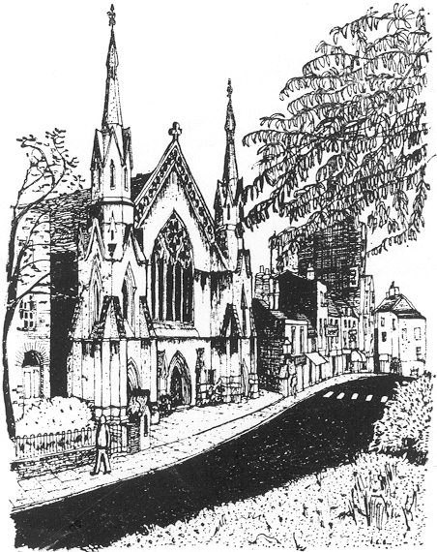

Minister: Ewan King
Newsletter No. 1022
From the Minister
‘The carol goes from door to door’
The carol goes from door to door,
A gift of God for rich & poor,
A song come down from his far throne,
A seed of light in darkness sown.
The carol brings, from door to door,
News of the lamb whom shepherds saw,
Held in a slumber still & deep,
Within a manger laid to sleep.
From God that night this song went forth:
Both west & east, both south & north,
Until our cold & clouded shore
First heard the name our hearts adore.
The carol goes from door to door,
Like Joseph once, so long before,
Soft through the night it makes its way,
Seeking some place for Christ to stay.
So clear and high the song rings on
When those who sing are passed and gone:
So from this world we too must pass
When God shall call us home at last.
With love
Ewan

Secretary’s news
Every time I write something in this newsletter about our building work, a new event makes a fool of me. Last month’s promise that we would soon see the back of our contractors was foiled by their slowing down so far that we had to renegotiate a completion date for the lower floor of 28 November (and I write this with no means of knowing if they will meet that deadline) and to delay the ground floor work until the start of January. I make no further comment and will not mention this work again until I can tell you it is complete, finished, ready for use, paid for and otherwise in the bag.
I was impressed by one Camden resident’s way of marking Advent. She has created an Advent challenge for herself by giving away one thing a day on the sharing website Streetbank, http://www.streetbank.com/. She makes the point that in a season when you inevitably add possessions, she will think about what she really needs and what she can find a better home for. Streetbank’s records suggest that for every six Camden residents doing this they would divert 1.3 tons from landfill.
On a smaller recycling scale, as Christmas is coming and you may receive the odd Christmas card in the post, can I encourage anyone handy for Heath Street to cut out used stamps from envelopes (with about half an inch margin around them) and leave them for me in the vestibule? The Baptist Union’s Home Mission makes a lot of money each year from selling stamps (and foreign coins and jewellery too – all welcome). If you start this at Christmas you may discover that it becomes such a habit you find yourself doing it automatically, and I’ll be happy to gather them up all year round and despatch them whenever I have a bagful.
With warm wishes for Christmas and a great start to 2015
Gaynor Humphreys

Clara Sanabras concert
I turned out to support our Community Choir on a recent Friday evening at the church, aware that they were performing with a singer called Clara Sanabras but not knowing what to expect. They were in a collaboration with two other choirs, Vox Holloway and Voices of Dissent, joining Clara in some of her fascinating mixture of music that ranged from collected, historic Catalan songs to her own work – settings of the songs from Shakespeare’s Tempest, a piece reflecting on displaced people in recent Iraqi troubles, and more. A memorable evening thanks to Clara’s attractive, powerful voice, and gracious and humorous direction of proceedings, the combined voices of three choirs, a string quintet plus oud, piano and percussion, and emotions stirred by songs written by or about people displaced from their roots or affected by war, or expressing unique cultural traditions.
It was good to know that we at Heath Street could offer our building for an evening like this, attracting a sizable audience, and contributing the musical skills of our Choir, John Baker (double bass) and Ewan King (on the piano and in the choir). The choir’s cake-making skills were evident in interval refreshments too!
It was a benefit event for the UNHCR’s Iraq appeal and at the first count some £1,000 was raised.
GH

Hampstead Christmas Festival
The Hampstead Christmas Festival was held on Sunday, the 23rd of November 2014. Most of the activities took place on the Hampstead High Street between the Tube Station and Pilgrim’s Lane; however, there were some special events at other venues. The doors opened at 10:30 a.m. at the Everyman for a greeting and entertainment by ShariFairy followed by a free screening of Arthur Christmas. Santa’s Grotto, as well as his reindeer and petting zoo, was outside the Tube Station this year. There were performances of Chickenshed Tales, as well as an exhibition of the artwork submitted for the Art Competition, at the Rosslyn Hill Unitarian Chapel. In Canine Corner (by Shepherd’s Walk), there was a Dog Competition and a Santa Paws Grotto. As always, there was a treasure hunt around the village beginning outside the Community Centre. Mr. Biddall brought all his lovely fun fair rides and there were stalls selling food and crafts lining the street. However, the big event was the Main Stage with entertainment beginning at noon and ending with an amazing performance by Angel Blue and the turning on of the lights by Jonathan Ross and some other local notables.
Susan Brandt
Thanks to Susan for all her hard work on this festival. Fierce cold and heavy rain may have kept the numbers a little lower than previous years, but they certainly didn’t damp the spirits of those who did come. At least not of my juvenile happy customers, who especially enjoyed the absence of cars from the High Street, bringing to mind Zechariah 8.5 - “The city streets will be filled with boys and girls playing there.”
Ewan King

James Melloy’s Maestà Grid
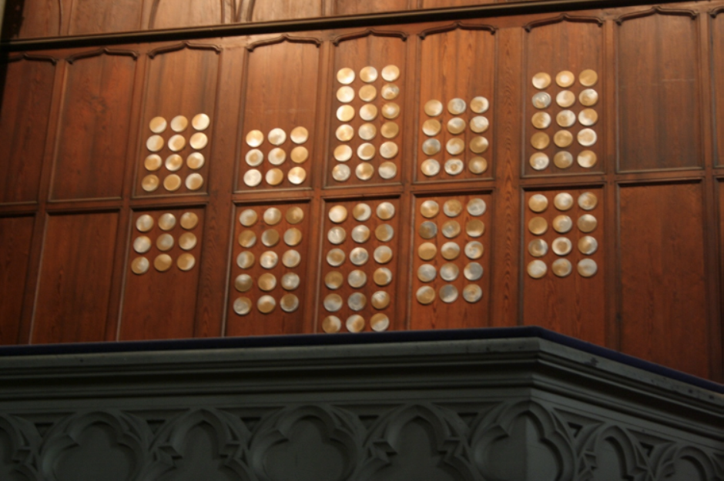
Advent is like a countdown and within any countdown there is anticipation and the possibility for success or failure. Maestà Grid formed by cells/discs is not symmetrical but shows a rhythm; a beat that is marked up and down with an emphasis on the central line. Similar to the job of an equaliser on an amplifier this is a document of various beats and rhythms.
Maestà refers to Duccio's multi panelled alter piece made for Siena Cathedral in the 14th Century, a piece that was cut up and spread around the museums and galleries of the world in the 18th Century. My cells/discs are moveable, transferable, morphic, structured for differing readings.
James Melloy

DAILY PRAYERS AND BIBLE READINGS
November 30th – December 6th 2 Kings 5.1-14
30th ‘Each day new praise resoundeth’
(Dec) 1st Robin Thorne
2nd John Walsh
3rd ‘All praise to him who came to save,
4th who conquered death and scorned the grave’
5th Tom Brandt
6th Joachim King
December 7th – 13th Isaiah 40.1-11
7th For the ministry of the Contact Club
8th Marie Isaacs
9th ‘Earth cannot give below / The bliss thou dost bestow’
10th ‘Midnight strikes! no more delaying’
11th Ewan King
12th Andrea MacEachan
13th For Syria
December 14th – 20th Isaiah 61.1-4, 8-11
14th ‘The Bridegroom comes in sight’
15th For children, parents and carers who attend Oldtime Nursery
16th ‘God's word feeds us, / rightly leads us, / life bestowing’
17th ‘Praise, O praise such love o'erflowing!’
18th For the members of our Community Choir
19th David & Eleanor Neil
20th ‘tell the story / of his glory’
December 21st – 27th 2 Samuel 7.1-11, 16
(December 25th Isaiah 62.6-12)
21st ‘till his praises / flood with light earth's darkest places!’
22nd Annie Fang
23rd ‘the friend whom none shall trust in vain’
24th Nesa Thorne
25th ‘O how blest that wondrous birthday,
26th When the Maid the curse retrieved’
27th Sharon Williams
December 28th – January 3rd Isaiah 61.10 – 62.3
28th ‘He is Alpha, from that Fountain
29th All that is and has been flows’
30th Edward Humphreys
31st Neil McLeod
1st Theresa Thom
2nd Hildegard Williams
3rd Susan Le Quesne
January 4th –10th Jeremiah 31.7-14
4th ‘He assumed this mortal body
5th Frail and feeble, doomed to die’
6th Margaret Smith
7th For Nigeria
8th HM
9th Lydia Baker
10th ‘Wheresoe’er ye be, ye faithful,
January 11th – 17th Genesis 1.1-5
11th Let your joyous anthems ring’
12th John Baker
13th For children, parents and carers who attend Oldtime Nursery
14th Ellie Kyungran Heo
15th ‘This is he, whom seer and sibyl
16th Sang in ages long gone by’
17th Anselm King
January 18th –24th 1 Samuel 3.1-20
18th Thaddeus King
19th Ethan McLeod
20th ‘Boys and girls together singing
21st With pure heart their song of praise’
22nd Frida King
23rd Avie Fang
24th Joachim King
January 25th – 31st Genesis 14.17-20
25th Euan McLeod
26th For the unity of the Church of Christ
27th ‘Sea and forest, frost and zephyr,
28th Day and night their Lord adore’
29th For the work of Henderson Court
30th Judith Peak
31st Susan Brandt
February 1st – 7th Deuteronomy 18.15-20
1st Gaynor Humphreys
2nd Chris Little
3rd Heini King
4th John Walsh
5th For the life and ministry of St. Mary’s, Hampstead
6th ‘He is Omega, of all things
7th Yet to come the distant Close’

WEEKLY ACTIVITIES
Sundays 11 am Divine Worship
8 pm Contact Club
Mondays 10 am ShowMeSpanish Rhyme Time
Tuesdays 10 am Oldtime Nursery
1 pm Lunchtime recital
2nd Tuesdays 7 pm Sacred Harp hymn singing
Wednesdays 4 pm After School Dance
5 pm Contemporary Technique (Foundation) Dance Class
6 pm Contemporary Technique (Intermediate) Dance Class
Thursdays 10 am Eeny Meeny Music
7:30 pm Heath Street Choir
Saturdays 10 am Hampstead Dutch School
Saturdays (alternate) 11 am Coffee morning

CHURCH DATES
December
Sunday 7th 11 am Visiting preacher Msgr. Phelim Rowland
Saturday 13th 6:30 pm Waking from Sleep
Sunday 14th 11 am Carol Service
Friday 19th 7 pm Kauneimmat joululaulut
(Finnish language carol service)
Sunday 21st 12.15 pm Church Christmas Lunch
Sunday 21st 8 pm Film Screening: It’s a Wonderful Life
(in association with the Philadelphia Association Film Club)
Wednesday 24th 11:30 pm Midnight Mass
Thursday 25th 10:30 am Christmas Day service
Sunday 28th 11 am Sacred Harp carol service
January
Sunday 4th 11 am The Lord’s supper

Church officers: Gaynor Humphreys (Church Secretary and Treasurer)
Anni Fang (Deacon)
Nesa Thorne (Deacon)

After the Sunday morning service:
don’t rush away
Please stay and have a cup of coffee with us in the vestibule.

To contact Ewan King
please e-mail: ewan_king@mac.com

Copy for the February Newsletter should reach Ewan King (ewan_king@mac.com)
not later than Wednesday 21 January

*** *** ***

Heath Street Baptist Church
84 Heath Street, Hampstead, London NW3 1DN
020 7431 0511
Web: www.heathstreet.org Twitter: @HeathStCHampst

