November 2014

NEWSLETTER

Heath Street Baptist Church
Hampstead

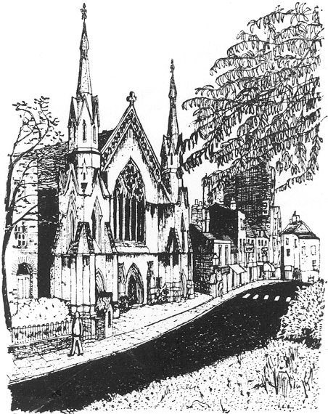

Minister: Ewan King
Newsletter No. 1021
Minister’s Letter
Ewan is on paternity leave!

Secretary’s news
There is a lot of news to share this month. Two welcome arrivals: Ethan Jack McLeod, a second son for Neil and Rebecca and Euan’s new little brother; and a new arrival at the manse, Thaddeus Toivo King – congratulations and good wishes to Ewan, Heini, Frida, Anselm and Joachim.
On the other hand there have been anxious moments after two accidents – a very serious one for Theresa Thom’s daughter Cathy, who suffered a fractured skull but has made a remarkable and rapid recovery and even been able to start work in a brand new job. Annie Fang’s daughter Avie shattered her elbow in a skating accident but seems to be bounding around again after surgery and managing to play her beloved chess one-handed. Both are very much in our prayers.
At the risk of being repetitive, let me provide an update on our work to install a new kitchen on our lower floor. We have had to face an unexpected problem: those of us at the Church meeting in October heard about this. The front stairs down to the lower floor – older members will remember them giving expensive trouble a dozen years ago – suffered a partial collapse which revealed a problem at the bottom where the two sets of stairs join. We were lucky that the problem happened when there were contractors on hand to prop up the staircase and secure it against anyone using it. Our structural engineer advised on the work needed to make it all safe and secure again and that work has been carried out. This is one of the reasons the timescale has slipped a bit (and the final bill has gone up). But with this extra work and delays caused by the specialist damp-proofers and our decision to go ahead with the ground floor tea point and accessible WC, we still have a finishing date of 14 November.
The Church meeting in October agreed that we should take a little breather before we do any further work. There is still a strong commitment to installing a lift, improving access from the street, ironing out some of the small steps and impediments inside the building and even redecorating (the first time since the centenary in 1961…). But to find the energy to make it all happen and be sure of having the funding to take the next steps will need some recovery time after this current phase.
The next Church meeting will be after the service on 7 December, and everyone with an interest in the future of Heath Street is welcome to take part. Discussion at the meeting will include a look at our finances – how we fund improvements, how we charge for use of our facilities (including the kitchen), and how we make the best and fullest use of our building.
Please take a look at the calendar this month for the many special events including advance warning of Christmas events. Huge thanks to everyone who brought food for the Contact Club, foliage and fruit for decoration, and financial contributions for Operation Agri, to our Harvest Service on 26 October.
With love and good wishes
Gaynor Humphreys

A letter from the Parfitts
Greetings to the fellowship at Heath Street from the Parfitts in Blagdon, North Somerset.
It is 25 years since we left London for the north and eventually returned to our roots in the southwest.
We have treasured memories of our time as members of the Heath Street church, of the friends we made there and of the blessings bestowed on us through the guidance not only of dear Edwin, but so many committed Christians who worshipped, worked and socialised with us. We are still in regular contact with some of those we met all those years ago, including Susan, and Sue LeQuesne who is living in a nursing home a couple of hours drive away. We have called in at Heath Street occasionally when we have visited London and have had the pleasure of meeting Ewan.
Important events we recall are the Mission we took part in, knocking doors all over Hampstead, witnessing to Christ and inviting people to “Come and See”, the re-starting of a Sunday School meeting in the vestry, a fun filled and instructive church study weekend away somewhere in the country, and on a practical note, putting in the window between the lobby and the sanctuary – a vision of Edwin’s to allow the passers-by to see into the church and observe for themselves that it is not a frightening place filled with odd people.
Here in Blagdon we worship at the Anglican Parish church and try to play our part in showing God’s love for His people in this place. Over the last two years our fellowship have managed to adapt the church building, as you are doing at Heath Street, to install modern facilities, lavatories, a kitchen etc. and opening it up throughout the week, to serve our rather isolated rural community. We now have Mother & Toddler groups, a Table Games afternoon for the lonely, Wi-Fi Wednesday, allowing people to keep in touch with family and friends who may be far away, and have, for church festivals expanded our worship services to sharing meals together. The church is now able to host concerts and exhibitions, there being no Village Hall here.
We continue to remember Heath Street and the fellowship there in our prayers, and beg that you think of us and our community here as together we seek to show our Lord’s love for His people.
Hazel and Colin

DAILY PRAYERS AND BIBLE READINGS
November 2nd – 8th Daniel 7.1-3, 15-18
2nd ‘For it is in giving that we receive’
3rd Ewan King
4th Nesa Thorne
5th ‘it is in pardoning that we are pardoned’
6th Andrea MacEachan
7th Edward Humphreys
8th ‘and it is in dying that we are born to eternal life.’
November 9th – 15th Lamentations 1.1-6
9th Susan Brandt
10th Anselm King
11th David and Eleanor Neil
12th Ethan McLeod
13th Marie Isaacs
14th HM
15th Gaynor Humphreys
November 16th – 22nd Jeremiah 2.4-13
16th Thaddeus King
17th Annie Fang
18th Hildegard Williams
19th Hazel and Colin Parfitt
20th Margaret Smith
21st Sharon Williams
22nd Frida King
November 23rd – 29th Genesis 22.1-14
23rd Ellie Kyungran Heo
24th Neil McLeod
25th Heini King
26th Euan McLeod
27th Theresa Thom
28th Judith Peak
29th Susan Le Quesne
November 30th - December 6th 2 Kings 5.1-14
30th ‘Each day new praise resoundeth’
(Dec) 1st Robin Thorne
2nd John Walsh
3rd ‘All praise to him who came to save,
4th who conquered death and scorned the grave’
5th Tom Brandt
6th Joachim King

WEEKLY ACTIVITIES
Sundays 11 am Divine Worship
8 pm Contact Club
Mondays 10 am ShowMeSpanish Rhyme Time
Tuesdays 10 am Oldtime Nursery
1 pm Lunchtime recital
2nd Tuesdays 7 pm Sacred Harp hymn singing
Wednesdays 4 pm After School Dance
5 pm Contemporary Technique (Foundation) Dance Class
6 pm Contemporary Technique (Intermediate) Dance Class
Thursdays 10 am Eeny Meeny Music
7:30 pm Heath Street Choir
Saturdays (alternate) 11 am Coffee morning

CHURCH DATES
November
Sunday 2nd 11 am The Lord’s supper
3 pm Bereavement Support Service
Saturday 8th 8 pm David Braid concert
Sunday 9th 10:45am Remembrance Day service
Friday 14th 8 pm Clara Sanabras: Concert
Saturday 22nd 6 pm LuteMusic New and Old: Concert
Fri 28th –Sat 29th 8 pm ‘Intersection’ dance workshops and performance
Saturday 29th 10 am Contemporary dance workshop
Sunday 30th 11 am Advent Sunday
December
Sunday 7th 11 am Visiting preacher Msgr. Phelim Rowland
TBC TBC Christmas Film Screenings
(in association with the Philadelphia Association Film Club)
- The Bishop’s Wife
- It’s a Wonderful Life
Saturday 13th 6:30 pm ‘Waking from Sleep’
Sunday 14th 11 am Carol Service
Sunday 21st 12.15 pm Church Christmas Lunch
Wednesday 24th 11:30 pm Midnight Mass
Thursday 25th 10:30 am Christmas Day service
Sunday 28th 11 am Sacred Harp carol service

Church officers: Gaynor Humphreys (Church Secretary and Treasurer)
Anni Fang (Deacon)
Rebecca McLeod (Deacon)
Nesa Thorne (Deacon)

After the Sunday morning service:
don’t rush away
Please stay and have a cup of coffee with us in the vestibule.

To contact Ewan King
please e-mail: ewan_king@mac.com

Copy for the December-January Newsletter should reach Ewan King (ewan_king@mac.com)
not later than Wednesday 19 November

*** *** ***

Heath Street Baptist Church
84 Heath Street, Hampstead, London NW3 1DN
Web: www.heathstreet.org Twitter: @HeathStCHampst

